AGREEMENT OF PURCHASE AND SALE

AND JOINT ESCROW INSTRUCTIONS

SUMMARY OF BASIC TERMS
This Agreement of Purchase and Sale and Joint Escrow Instructions (the “Agreement”), dated as of the “Effective Date” set forth in Section 1 of the Summary of Basic Terms, below, is made by and between Hoh chuEn hwa hao (“Seller”) and ACRE INVESTMENT COMPANY, LLC, a California limited liability company (“Buyer”). The terms as set forth below shall have the meanings ascribed to such terms as set forth below when used in this Agreement.
This Agreement supersedes and replaces that certain Real Estate Purchase Agreement dated March 4, 2024 between David How and Seller, as amended by a March 7, 2024 Amendment to Real Estate Purchase Contract.
SUMMARY OF BASIC TERMS
TERMS | DESCRIPTION
Effective Date: | The date of Escrow Holder's signature acknowledging receipt of a fully executed copy of this Agreement
Purchase Price: | Nine Million Four Hundred Thousand Dollars ($9,400,000.00)
Deposit: | One Million Dollars ($1,000,000.00), together with interest thereon.
Escrow or Escrow Holder: | Fidelity National Title Company  Escrow Officer: Kimberleigh Toci  Title Officer: Kevin Davis  Title Officer Phone: (415) 276-0220  Order No.: 013-30110922-A-KD9
Contingency Date: | Twenty One (21) Business Days following March 4, 2024 (i.e., April 2, 2024)
Closing Date: | Two (2) Business Days following Approval of Feasibility (i.e., no later than April 4, 2024)
Real Property: | That certain real property described in Exhibit A and commonly known as 2715 Dwight Way, Berkeley, California (APN: 055-1867-010-00) consisting of 28-unit multifamily property, together with all easements, covenants, rights, privileges, tenements, hereditaments and appurtenances thereunto now or hereafter belonging or appertaining thereto, together with all right, title and interest of Seller in and to any and all improvements, structures and permanent fixtures located thereon.
Intangible Property: | The following intangible personal property, to the extent it is transferable, which is related to the ownership or operation of the Property: (i) any and all development rights, entitlements, permits, approvals, authorizations, licenses and consents obtained from any Authority (defined below) in connection with the development, use, or operation of the Property; (ii) mineral rights, oil and gas rights, water, water rights, air rights and any and all utility rights; (iii) all rights, indemnities, warranties, claims and any similar rights relating to and benefiting the Real Property; (iv) all reports, studies, plans, specifications, maps, drawings and other renderings, and (v) all intangible rights, goodwill and similar rights benefiting the Real Property.
Leases: | Those certain leases described on Schedule 1.9 hereto.
Property: | The Real Property, Intangible Property and Leases, collectively.
Title Company: | Escrow Holder
City: | City of Berkeley
County: | County of Alameda
State: | State of California
Authority: | Any governmental or quasi-governmental body or agency having jurisdiction over the Property and/or Seller with respect to the Property, including, without limitation, the State, City and the County.

PURCHASE

Purchase Price; Escrow Opening.
Seller agrees to sell to Buyer, and Buyer agrees to purchase from Seller, the Property in accordance with the provisions of this Agreement for the sum of the Purchase Price, which shall be paid as set forth below in this Section 2.1. Seller hereby acknowledges the receipt of funds in the amount of One Hundred Dollars ($100.00) (the “Independent Contract Consideration”) from the Deposit, which amount the parties bargained for and agreed to as consideration for Buyer’s right to inspect and purchase the Property pursuant to this Agreement and for Seller’s execution, delivery and performance of this Agreement. The Independent Contract Consideration is in addition to and independent of any other consideration or payment provided in this Agreement, is nonrefundable, and is fully earned and shall be retained by Seller notwithstanding any other provision of this Agreement.

Deposit. Within one (1) business day after the Effective Date, Buyer shall deliver to Escrow Holder the sum of the Deposit, which Escrow Holder shall invest at the request of Buyer in a federally-insured, interest bearing account. All interest which accrues on the Deposit shall be credited to the principal balance of the Deposit. Seller acknowledges receipt of a prior deposit in the amount of $50,000.00 (which amount was paid by David How to Seller outside of Escrow, shall be retained by Seller, and shall not be credited toward the Deposit due from Buyer hereunder). Upon Approval of Feasibility, the Deposit shall, except as otherwise set forth herein, become non-refundable to Buyer, provided, however, that upon the Close of Escrow, the Deposit shall be applied toward the Purchase Price.

Purchase Price Balance. On or prior to the Closing (within such time for the Closing to occur on the Closing Date), Buyer shall deliver to Escrow Holder the balance of the Purchase Price as follows. Buyer shall deliver into Escrow an executed original of a promissory note in the principal amount of Four Million Seven Hundred Thousand Dollars ($4,700,000) (the “Loan”), in the form of EXHIBIT E to this Agreement (the “Promissory Note”) and cash, in immediately available funds, in amount sufficient to pay the then remaining balance of the Purchase Price, plus Buyer’s share of costs and expenses plus or minus applicable prorations and reimbursements. The Promissory Note shall be secured by a Deed of Trust, Assignment of Leases and Rents and Fixtures Filing against the Property, executed by Buyer in favor of Seller, in the form of EXHIBIT F to this Agreement.

Escrow Opening. Buyer and Seller have opened “Escrow” with the Escrow Holder for the consummation of the transaction described in this Agreement. Within one (1) business day following the execution and delivery of this Agreement between the parties, the parties shall deliver a fully executed copy of this Agreement to Escrow Holder. Escrow shall close (“Closing” or “Close of Escrow”) on the Closing Date, or such date as may be agreed upon by the parties in writing.

Buyer’s Due Diligence.
Prior to the Contingency Date, Buyer shall review and approve or disapprove in its sole and absolute discretion, as hereafter provided, all aspects of the Property, including, without limitation (i) the Real Property, (ii) the physical and environmental condition of the Real Property, (iii) the financial condition of the Property, including, without limitation, the feasibility, convertibility, desirability and suitability of the Property for Buyer's intended use and purposes, (iv) the legal condition of the Property, including, without limitation, compliance or non-compliance with all statutes, ordinances, codes, regulations, decrees, orders and laws applicable to the Property, (v) the financing of the acquisition, (vi) the existence or non-existence of any governmental or quasi-governmental entitlements, if any, affecting the Property or any portion of the Property, (vii) any dimensions or specifications of the Property or any part thereof, (viii) the zoning, building and land use restrictions applicable to the Property or any portion thereof, and (ix) all other matters which Buyer deems relevant to its purchase of the Property, as follows:

Physical Inspections. Subject to the rights of any tenants at the Real Property, Buyer and Buyer’s representatives, agents, contractors, consultants, employees and designees shall have the right and license from Seller to enter upon the Real Property from time to time during reasonable business hours, upon not less than 24 hours’ prior notice to Seller, at Buyer’s sole cost, for any purpose in connection with its proposed purchase, development or operation of the Property, including, without limitation, to make such inspections, investigations and tests as Buyer may elect to make or obtain (collectively, “Buyer’s Inspections”). Notwithstanding the foregoing, Buyer shall not be permitted to conduct any invasive or destructive testing at or on the Real Property without the prior written consent of Seller. Seller shall reasonably cooperate with Buyer to facilitate Buyer's Inspections at no cost to Seller upon reasonable notice to Seller. Buyer shall repair any damage, and agrees to indemnify and hold Seller harmless from and against any injury to persons or damage to the Property, to the extent caused by Buyer, its representatives, agents, contractors, consultants, employees or designees in connection with Buyer's Inspections, or any mechanic's liens arising out of Buyer's investigations, provided, however, that this indemnity shall not extend either (i) to the extent of any negligence or misconduct of Seller or any representative, agent, contractor, consultant, tenant or employee of Seller or its affiliates, or (ii) to Buyer’s mere discovery of pre-existing conditions on the Property. The foregoing indemnity shall survive the Close of Escrow or the termination of this Agreement. Buyer shall maintain for itself and on behalf of its consultants and contractors, or Buyer shall maintain and shall ensure that its agents, consultants and contractors maintain, commercial general liability insurance insuring against any liability arising out of any entry, tests or investigations of the Property pursuant to the provisions hereof. Such insurance maintained by Buyer and/or its consultants, agents and contractors (as applicable) shall be in the amount of One Million Dollars ($1,000,000) combined single limit for injury to or death of one or more persons in an occurrence, and for damage to tangible property (including loss of use) in an occurrence. The policy maintained by Buyer shall insure the contractual liability of Buyer covering the indemnities herein and shall (i) name Seller and its property manager as additional insureds, (ii) contain a cross-liability provision, and (iii) contain a provision that the insurance provided by Buyer hereunder shall be primary and non-contributing with any other insurance available to Seller. Buyer shall provide Seller with evidence of such insurance coverage prior to any entry, tests or investigations of the Property.

Property Information. Within two (2) business days of the Effective Date, Seller shall provide to Buyer (via Dropbox or other electronic means) copies of the following documents and/or information pertaining to the Property, to the extent any of the same is in Seller’s possession or reasonable control: all rental agreements (including any amendments, addenda or letter agreements, etc.), and leases; accounts receivable reports, and a current rent roll; all environmental, engineering, seismic and property condition reports; all "as-builts"; any existing ALTA survey covering the Property; all certificates of occupancy for the Property; any licenses and permits affecting the Property; any service contracts for the Property; any zoning/land use applications and/or approvals for the Property; and any material correspondence related to the Property (collectively, the “Property Information”). Seller shall provide Buyer with copies of such other information pertaining to the Property in Seller’s possession or reasonable control if reasonably requested by Buyer.

Title Inspection. Buyer has obtained a preliminary title report (“Title Report”) issued by the Title Company covering the Real Property. Buyer shall have from the Effective Date until five (5) business days prior to the Contingency Date (the “Title Review Period”) within which to notify Seller of any exceptions to title as shown in the Title Report which Buyer disapproves. Any exceptions which are timely disapproved by Buyer pursuant to this section shall be referred to collectively as the “Title Objections”. If Buyer fails to notify Seller of its disapproval of any matters shown in the Title Report within the Title Review Period, Buyer shall conclusively be deemed to have approved such matters. Any such matter not disapproved in writing by Buyer within the Title Review Period shall constitute a “Permitted Exception” hereunder. If Buyer notifies Seller of any Title Objections within the Title Review Period then, at Seller’s sole discretion, Seller may elect (but shall not be obligated) to remove or cause to be removed any of the Title Objections at Seller’s expense, or to cause any Title Objections to be insured against by the Title Company, which removal will be deemed achieved by the issuance of title insurance insuring against the effect of the Title Objections or removal of such exception from the Title Report, in each case subject to Buyer’s reasonable approval. Seller shall notify Buyer in writing (“Seller’s Title Notice”) within three (3) business days after receipt of Buyer’s notice of Title Objections (“Seller’s Cure Notice Period”) whether Seller elects to remove or to cause the Title Company to insure against the same, and, by the Closing Date, Seller shall remove or cause the Title Company to insure against those Title Objections elected to be removed or insured against by Seller in Seller's Title Notice. Seller’s failure to deliver Seller’s Title Notice to Buyer shall constitute Seller’s election not to cure such Title Objections. Notwithstanding the foregoing, Seller agrees to remove the following as exceptions to title to the Property prior to the Closing Date (i) all delinquent taxes and assessments and interest and penalties thereon, if any, (ii) all delinquent installments and accrued interest due on any bonds affecting the Property, (iii) mortgages, deeds of trust, security instruments and financing statements, (iv) mechanic’s liens not created by Buyer or resulting from Buyer’s Inspections, and (v) any exceptions or encumbrances to title which are created by, through or on account of Seller after the Effective Date without the written consent of Buyer (and not otherwise approved by Buyer).

If Seller elects or is deemed to have elected not to cause any Title Objections to be removed or insured against prior to the Closing Date, Buyer may elect by notice to Seller on or before the Contingency Date to terminate this Agreement, in which event each party shall promptly execute and deliver to Escrow Holder such documents as Escrow Holder may reasonably require to evidence such termination, the Deposit (less the Independent Contract Consideration) shall be returned to Buyer, and the respective obligations of Buyer and Seller under this Agreement shall terminate, except as to matters which expressly survive termination. Buyer’s failure to give such notice of termination on or before such date shall constitute Buyer’s waiver of any Title Objections which Seller is unwilling to cure, in which event such Title Objections shall be deemed to be Permitted Exceptions and the Closing shall occur as herein provided.

Contingency Date. Buyer shall have until 5:00 p.m. (Pacific) on the Contingency Date (“Approval Time”) in which to approve or disapprove, in Buyer’s sole and absolute discretion, the Property Information and any and all inspections, investigations, tests and studies set forth in Section 2.2. If Buyer provides its written approval (“Approval of Feasibility”), this Agreement shall continue in full force and effect. In the event Buyer determines the Property is not acceptable to Buyer in accordance with the immediately preceding sentence, Buyer shall have the right to terminate this Agreement by delivering notice to Seller of its election to terminate pursuant to this Section 2.2(d) at or before the Approval Time. In the event Buyer has not provided Seller, by the Approval Time, with its approval or disapproval, Buyer’s inspections, investigations, tests and studies set forth in Section 2.2 shall be deemed to be disapproved. Upon Buyer’s disapproval or deemed disapproval, this Agreement shall terminate and each party shall promptly execute and deliver to Escrow Holder such documents as Escrow Holder may reasonably require to evidence such termination, the Deposit shall be returned to Buyer, and the respective obligations of Buyer and Seller under this Agreement shall terminate, except as to matters which expressly survive termination. If Buyer elects to terminate this Agreement as provided herein, then upon request of Seller, Buyer shall deliver to Seller, without representation, warranty or recourse, copies of all third-party reports (the “Reports”) produced for or obtained by Buyer in connection with Buyer’s investigation of the Property, including any property condition assessment, structural or roof report, phase I environmental site assessment or other environmental reports, soils or geotechnical reports, or ALTA survey; provided, however, that in no event shall Buyer be obligated to deliver to Seller any internal memoranda, work product, or confidential or privileged information.

Conditions Precedent to Buyer’s Obligations.
The obligations of Buyer to consummate the transactions provided for herein are subject to and contingent upon the satisfaction of the following conditions or the waiver of the same by Buyer in writing:

Covenants of Seller. Seller shall have materially performed each and every covenant and agreement to be performed by Seller hereunder by the time and in the manner required by the terms of this Agreement.

Representations and Warranties of Seller. Seller’s representations and warranties under Article 4 shall be true and correct in all material respects both as of the Effective Date and as of the date of Closing with the same force and effect as if remade by Seller in a separate certificate at that time.

Title Policy. The Title Company shall have irrevocably committed at Closing to issue a 2006 ALTA Owner’s Policy of Title Insurance with endorsements and affirmative coverage approved by Buyer, subject only to the Permitted Exceptions.

Conditions Precedent to Seller’s Obligations.
The obligations of Seller to consummate the transactions provided for herein are subject to and contingent upon the satisfaction of the following conditions or the waiver of the same by Seller in writing:

Covenants of Buyer. Buyer shall have materially performed each and every covenant and agreement to be performed by Buyer hereunder by the time and in the manner required by the terms of this Agreement.

Representations and Warranties of Buyer. Buyer’s representations and warranties under Article 4 shall be true and correct in all material respects both as of the Effective Date and as of the date of Closing with the same force and effect as if remade by Buyer in a separate certificate at that time.
(c) Loan Policy. The Title Company shall have irrevocably committed at Closing to issue a 2006 ALTA Lender’s Policy of Title Insurance in the amount of the Loan, with endorsements and affirmative coverage approved by Seller, subject only to the Permitted Exceptions (the “Loan Policy”).

Failure of Conditions to Close of Escrow.
If by the Closing Date any of the conditions set forth in Sections 2.3 or 2.4 are not satisfied or waived, then unless otherwise agreed between the parties to extend the Closing Date, (a) each party shall promptly execute and deliver to Escrow Holder such documents as Escrow Holder may reasonably require to evidence the termination of this Agreement and the Escrow, (b) the respective obligations of Buyer and Seller under this Agreement shall terminate (except as to matters which expressly survive termination of this Agreement), and (c) if the failure of condition giving rise to the termination is a condition under Section 2.3, Escrow Holder shall remit the Deposit (less the Independent Contract Consideration) together with any accrued interest on such funds to Buyer, and if the failure of condition giving rise to the termination is a condition under Section 2.4, Escrow Holder shall remit the Deposit together with any accrued interest on such funds to Seller. The foregoing shall not operate as a waiver of any rights or remedies that a party may have by reason of a default or breach of this Agreement by the other party.
2.6 AS IS SALE.
EXCEPT FOR SELLER’S EXPRESS REPRESENTATIONS, WARRANTIES AND COVENANTS IN THIS AGREEMENT AND IN THE CLOSING DOCUMNTS, BUYER SPECIFICALLY ACKNOWLEDGES AND AGREES THAT SELLER IS SELLING AND BUYER IS PURCHASING THE PROPERTY ON AN “AS IS WITH ALL FAULTS” BASIS AND THAT BUYER IS NOT RELYING ON ANY REPRESENTATIONS OR WARRANTIES OF ANY KIND WHATSOEVER, EXPRESS OR IMPLIED, FROM SELLER, ANY SELLER RELATED PARTIES, OR THEIR AGENTS OR BROKERS, OR ANY OTHER PERSON ACTING OR PURPORTING TO ACT ON BEHALF OF SELLER AS TO ANY MATTERS CONCERNING THE PROPERTY.

CLOSING

Escrow; Closing.
Upon the execution of this Agreement by Buyer and Seller, and delivery of the executed Agreement to Escrow Holder, this Agreement shall constitute the joint escrow instructions of Buyer and Seller to Escrow Holder to open Escrow for the consummation of the sale of the Property to Buyer pursuant to the terms of this Agreement. Buyer and/or Seller may deliver escrow instructions supplementing the escrow instructions contained in this Agreement; provided, however, that if there is any conflict or inconsistency between such supplemental escrow instructions and this Agreement, this Agreement shall control.

Deposits Into Escrow.

By Seller. On or prior to the Closing Date, Seller shall deposit into Escrow:

A deed in the form of Exhibit B, in recordable form (the “Grant Deed”);

Two (2) original counterparts of a General Assignment in the form of Exhibit C, duly executed by Seller (the “General Assignment”);

Two (2) original counterparts of a Lease Assignment in the form of Exhibit D, duly executed by Seller (the “Lease Assignment”);

An affidavit or qualifying statement which satisfies the requirements of Section 1445 of the Internal Revenue Code of 1986, as amended, and the regulations thereunder in form acceptable to Buyer (the “Non-Foreign Affidavit”); and

A “Withholding Exemption Certificate, Form 593,” pursuant to California Revenue and Taxation Code Sections 18805 and 26131 or its equivalent stating that Seller is exempt from such withholding requirement (the “Withholding Exception Certificate”); and

Such documents of Seller authorizing the sale of the Property to Buyer as are reasonably required by the Title Company, including, without limitation, any required owner’s affidavit and authority documentation.

By Buyer. On or prior to the Closing Date, Buyer shall deposit into Escrow:

The balance of the Purchase Price, plus Buyer’s share of costs and expenses plus or minus applicable prorations, less $4,700,000.00 (representing the principal amount of the Promissory Note (defined below));

Two (2) original counterparts of the General Assignment duly executed by Buyer;

Two (2) original counterparts of the Lease Assignment duly executed by Buyer;

Such documents of Buyer authorizing the purchase of the Property by Buyer as are reasonably required by the Title Company.
(5) A Promissory Note in the form of Exhibit E, duly executed by Buyer; and
(6) A Deed of Trust in the form of Exhibit F, in recordable form, to be recorded immediately after the Deed.

Closing Costs.

Seller’s Costs. Seller shall bear, and Escrow Holder shall deduct from sums otherwise payable to Seller hereunder, all costs and charges customarily charged to sellers in accordance with common escrow practices in the County, i.e., Seller shall pay the County documentary transfer tax and one-half (1/2) of the City transfer tax.

Buyer’s Costs. Buyer shall bear, and Buyer shall deposit with Escrow Holder for disbursement by Escrow Holder hereunder, all costs and charges customarily charged to buyers in accordance with common escrow practices in the County, i.e., Buyer shall pay all escrow fees, the premium for the Title Policy and any endorsements requested by Buyer, the premium for the Loan Policy, the recording fees for the Deed and the Deed of Trust, and one-half (1/2) of the City transfer tax.

Prorations. The following items shall be prorated and adjusted between Seller and Buyer as of the Closing Date, with Seller being entitled to or responsible for such items through the day prior to the Closing Date and Buyer being entitled to or responsible for such items for the Closing Date and thereafter, except as otherwise specified.

Taxes and Assessments. All non-delinquent real estate taxes and assessments payable with respect to the Property shall be prorated between Seller and Buyer as of the Closing Date for the year in which the Closing is held on the basis of the statements for such amounts for such year. If statements for the current year are not available as of the Closing Date, the proration between Seller and Buyer shall be made on the basis of the amounts due for the immediately prior year and shall be subject to adjustment in cash after the Closing outside of escrow within sixty (60) days after the bills for the applicable period are received. If any tax assessment for the current or prior year is under protest, the closing tax proration shall be re-prorated between Buyer and Seller at such time as there is a final determination on such protest. The provisions of this Section 3.2(d) shall survive the Closing.

Rentals. All rentals and other payments due from any tenants and other persons using or occupying the Property or any part thereof under the Leases, or otherwise payable for or in connection with any such use or occupancy, which are actually collected. Delinquent rents shall not be prorated on the Closing Date but shall be prorated upon receipt of such delinquent rents by either Buyer or Seller in accordance with the following sentence. Payments received from any tenants from and after the Closing Date shall be applied first to rents then due for the current period, then to any other amounts past due and owing to Buyer, and then to rents delinquent as of the Closing Date. Seller shall not have the right to seek the collection of delinquent rentals owing from any tenant or to seek to enforce any rights under the Leases after the Closing

Contracts. Charges accrued for the billing period including the date of Close of Escrow on service contracts assumed by Buyer, if any. Buyer shall notify Seller in writing on or before the Closing Date as to which service contract(s) Buyer elects to assume at Closing. All other service contracts shall be terminated by Seller.

Prepayments. All security deposits held by Seller pursuant to the Leases and any prepaid rentals or prepaid payments due under the Leases which cover any period after the Closing shall belong to Buyer upon the Close of Escrow and shall be credited to Buyer at the Close of Escrow.

Services. Gas, water, electricity, heat, fuel, sewer and other utilities, as well as other operating expenses relating to the Property. It shall be assumed that utility charges were uniformly incurred during the billing period in which the date of Close of Escrow occurs for purposes of making such prorations.

Prorations Statement. Seller and Buyer shall, no later than five (5) business days before the Closing Date, prepare a statement containing all of the prorations of income and expenses required hereunder and deliver the statement approved by Seller and Buyer to Escrow Holder on the business day prior to the Closing Date. Each of Buyer and Seller shall act reasonably and in good faith in preparing such statement.

REPRESENTATIONS AND WARRANTIES

Seller’s Representations and Warranties.
The following constitute representations and warranties of Seller to Buyer which shall be true and correct as of the date hereof and the Closing as if remade in a separate certificate at that time:

Organization. Seller resides in the State of California.

Authority. Seller has the legal power, right and authority to enter into this Agreement and the instruments referenced herein, and to consummate the transactions contemplated hereby. No joinder, consent, or waiver of or by any third party is necessary to permit the consummation by Seller of the transaction contemplated pursuant to this Agreement and the execution, delivery and performance of this Agreement by Seller does not and will not constitute a breach or default by Seller under any agreement, order, contract, document or judgment by which Seller or the Property is bound or under any law, statute, ordinance or regulation to which Seller or the Property is subject.

Bankruptcy. Seller has not filed any voluntary petition in bankruptcy or suffered the filing of any involuntary petition by Seller’s creditors or suffered the appointment of a receiver to take possession of the Property.

Litigation. There are no actions or proceedings pending or, to Seller’s knowledge, threatened against Seller that Seller reasonably expects would affect the validity or enforceability of this Agreement or closing documents to be executed and delivered by Seller pursuant to this Agreement.

Leases. Other than the Leases set forth on Schedule 1.9, there are no leases, license agreements or occupying agreements (or any amendments or supplements thereto) that will bind or encumber the Property following Closing. There are no allowances, monetary inducements, commissions or credits due or owed under the Leases that will remain outstanding as of the Closing Date.

Condemnation. Seller has not received written notice of any currently pending or threatened Condemnation of all or any portion of the Property.

Violations. Seller has received no written notice from any source alleging that the Property is in material violation of applicable laws (including, without limitation, environmental laws), ordinances or regulations which has not been cured, dismissed, settled or otherwise resolved.

Environmental. Except as may be disclosed in the Property Information, to Seller's knowledge, there has been no use, production, disposal, release or storage on or about the Property of any Hazardous Materials (as hereinafter defined) in violation of Environmental Laws. The term "Hazardous Materials" shall mean and include any hazardous substance, pollutant, contaminant, material, waste, by-product or constituent which is or becomes regulated by any local governmental authority, the State of California or the United States Government, including, without limitation, any substance, material, waste or by-product regulated by any "Environmental Laws." The term "Environmental Laws" shall mean and include all federal, state and local statutes, ordinances, regulations and rules then in effect relating to environmental quality, health, safety, contamination and clean-up.

Property Information. To Seller's knowledge, Seller has delivered all Property Information to Buyer and such Property Information is complete and accurate in all material respects and does not contain any untrue statement of material fact or omit to state a material fact necessary to make the statements or facts contained therein not misleading.

No Purchase Options. Seller has not granted any option or right of first refusal to any party to acquire Seller’s ownership interest in the Property.

No Defaults. To Seller’s knowledge, Seller is not in default under, and Seller has not received any notice that any event has occurred which with the giving of notice or the passage of time, or both, would constitute a default under any contract, transaction, agreement, covenant, condition, restriction, lease, easement, encumbrance or instrument pertaining to the Property.

No Undisclosed Agreements. Seller has made no undisclosed oral or written commitments or representations to, or understandings or agreements with, any person, firm or entity, any adjoining property owner or any governmental authority which would in any way be binding on Buyer following the Closing.

Land Use. Seller has not entered into, and has no knowledge of, any agreement with or pending application to any Authority with respect to any zoning modification, variance, redevelopment, exception, subdivision, platting or other matter.

Non-Foreign Assets. To Seller’s knowledge, Seller is in compliance with the requirements of Executive Order No. 13224, 66 Fed Reg. 49079 (September 25, 2001) (the “Order”) and other similar requirements contained in the rules and regulations of the Office of Foreign Asset Control, Department of the Treasury (“OFAC”) and in any enabling legislation or other Executive Orders in respect thereof (the Order and such other rules, regulations, legislation, or orders are collectively called the “Orders”). Seller:

is not listed on the Specially Designated Nationals and Blocked Persons List maintained by OFAC pursuant to the Order and/or on any other list of terrorists or terrorist organizations maintained pursuant to any of the rules and regulations of OFAC or pursuant to any other applicable Orders (such lists are collectively referred to as the “Lists”);

has not been determined by competent authority to be subject to the prohibitions contained in the Orders; and

does not act for or on behalf of, any person or entity on the Lists or any other person or entity that has been determined by competent authority to be subject to the prohibitions contained in the Orders.

The representations and warranties of Seller in this Section 4.1 shall survive the Closing for a period of six (6) months after the Closing (the “Survival Period”). Notice of any claim based on any of the foregoing representations and warranties must be delivered to Seller, if at all, before the end of the Survival Period. Whenever in this Agreement a representation or warranty is being made to Seller’s knowledge, such qualification indicates that the warranty is being made to the current actual knowledge of Seller, without any implied, imputed or constructive knowledge and without any independent investigation having been made or any implied duty to investigate. Seller shall have no liability to Buyer for a breach of any representation or warranty unless written notice containing a description of the specific nature of such breach shall have been given by Buyer to Seller prior to the expiration of the Survival Period and any action shall have been commenced by Buyer against Seller within the Survival Period. Except as expressly set forth in this Agreement, Seller has not made any warranty or representation, express or implied, written or oral, concerning the Property.

Buyer’s Representations and Warranties.
The following constitute representations and warranties of Buyer to Seller which shall be true and correct as of the date hereof and the Closing as if remade in a separate certificate at that time:

Organization. Buyer is duly organized, validly existing and in good standing under the laws of California.

Authority. Buyer has the legal power, right and authority to enter into this Agreement and the instruments referenced herein, and to consummate the transactions contemplated hereby. All requisite action (corporate, trust, partnership or otherwise) has been taken by Buyer in connection with the entering into this Agreement and the instruments referenced herein, and the consummation of the transactions contemplated hereby. No joinder, consent, or waiver of or by any third party is necessary to permit the consummation by Buyer of the transaction contemplated pursuant to this Agreement and the execution, delivery and performance of this Agreement by Buyer does not and will not constitute a breach or default by Buyer under any agreement, order, contract, document or judgment by which Buyer is bound or under any law, statute, ordinance or regulation to which Buyer is subject. The person executing this Agreement on behalf of Buyer is duly authorized to do so.

Bankruptcy. Buyer has not filed any voluntary petition in bankruptcy or suffered the filing of any involuntary petition by Buyer’s creditors or suffered the appointment of a receiver to take possession of the Property.

Litigation. There are no actions or proceedings pending or, to Buyer’s knowledge, threatened against Buyer that Buyer reasonably expects would affect the validity or enforceability of this Agreement or closing documents to be executed and delivered by Buyer pursuant to this Agreement.

Non-Foreign Assets. Buyer is in compliance with the requirements of the Orders. Buyer:

is not listed on the Lists;

has not been determined by competent authority to be subject to the prohibitions contained in the Orders; and

is not directly owned or controlled by, nor acts for or on behalf of, any person on the Lists or any other person that has been determined by competent authority to be subject to the prohibitions contained in the Orders.
4.3 Buyer’s Release. Except for the express representations and warranties of Seller set forth in this Agreement, Buyer on its own behalf and on behalf of Buyer’s members, managers, officers, agents and affiliates hereby agrees that, as of the Closing, each of Seller, her heirs, legal representatives and agents shall be, and are hereby, fully and forever released and discharged from any and all any liabilities, claims, demands, judgments, causes of action, losses, costs, damages, penalties, fines, taxes, remedial actions, removal and disposal costs, investigation and remedial costs and expenses (including, without limitation, attorneys’, experts’ and consultants’ fees) (collectively, “Claims”), whether direct or indirect, known or unknown, foreseen or unforeseen, that may arise on account of or in any way connected with the Property including, without limitation, the physical, environmental and structural condition of the Real Property or any law or regulation applicable thereto, including, without limitation, any Claim (regardless of when it first appeared) relating to or arising from (i) the use, presence, storage, release, discharge, or migration of Hazardous Materials on, in, under or around the Property regardless of when such Hazardous Materials were first introduced in, on or about the Property, (ii) any patent or latent defects or deficiencies with respect to the Property, (iii) any and all matters related to the Property or any portion thereof, including without limitation, the condition and/or operation of the Property and each part thereof, and (iv) the presence, release and/or remediation of asbestos and asbestos containing materials in, on or about the Property regardless of when such asbestos and asbestos containing materials were first introduced in, on or about the Property. Buyer hereby waives and agrees not to commence any action, legal proceeding, cause of action or suits in law or equity, of whatever kind or nature, including, but not limited to, a private right of action under the federal superfund laws, 42 U.S.C. Sections 9601 et seq. and California Health and Safety Code Sections 25300 et seq. (as such laws and statutes may be amended, supplemented or replaced from time to time), directly or indirectly, against Seller and the Indemnitees or their agents in connection with Claims described above and expressly waives the provisions of Section 1542 of the California Civil Code which provides:
A GENERAL RELEASE DOES NOT EXTEND TO CLAIMS THAT THE CREDITOR OR RELEASING PARTY DOES NOT KNOW OR SUSPECT TO EXIST IN HIS OR HER FAVOR AT THE TIME OF EXECUTING THE RELEASE AND THAT, IF KNOWN BY HIM OR HER, WOULD HAVE MATERIALLY AFFECTED HIS OR HER SETTLEMENT WITH THE DEBTOR OR RELEASED PARTY.
and all similar provisions or rules of law. Buyer elects to and does assume all risk for such Claims heretofore and hereafter arising, whether now known or unknown by Buyer. The aforementioned release shall not include or be applicable to any Claims arising out of the entry into or performance of this Agreement by Seller nor any Claims directly resulting from or relating to a breach by Seller of any of the representations made in Section 4.1 hereof so long as any such Claim (in each instance) is made by Buyer within the Survival Period specified in Section 4.1 above. After the expiration of the Survival Period, the aforementioned release will also include all Claims resulting from or relating to any breach by Seller of the representations made in Section 4.1 of this Agreement. In this connection and to the greatest extent permitted by law, Buyer hereby agrees, represents and warrants that Buyer realizes and acknowledges that factual matters now unknown to it may have given or may hereafter give rise to causes of action, claims, demands, debts, controversies, damages, costs, losses and expenses which are presently unknown, unanticipated and unsuspected, and Buyer further agrees, represents and warrants that the waivers and releases herein have been negotiated and agreed upon in light of that realization and that Buyer nevertheless hereby intends to release, discharge and acquit Seller from any such unknown Claims, debts, and controversies which might in any way be included as a material portion of the consideration given to Seller by Buyer in exchange for Seller's performance hereunder. Without limiting the foregoing, if prior to the Closing Buyer has actual knowledge of (a) a default by Seller in any of the covenants, agreements or obligations to be performed under this Agreement and/or (b) any breach or inaccuracy in any representation of Seller made in this Agreement, and Buyer nonetheless elects to proceed to Closing, then Buyer shall have conclusively deemed to have waived any such default and/or breach or inaccuracy and shall have no Claim against Seller hereunder with respect thereto.
Seller has given Buyer material concessions regarding this transaction in exchange for Buyer agreeing to the provisions of this Section 4.3. Seller and Buyer have each initialed this Section 4.3 to further indicate their awareness and acceptance of each and every provision hereof. The provisions of this Section 4.3 shall survive the Closing and/or any expiration or earlier termination of this Agreement and shall not be deemed merged into any instrument or conveyance delivered at the Closing.
SELLER'S INITIALS: ______ BUYER'S INITIALS: _____

CONDEMNATION, DAMAGE AND DESTRUCTION

Condemnation.
If, prior to the Closing, any portion of the Real Property is taken, by eminent domain or otherwise (or is the subject of a pending, threatened or contemplated taking which has not been consummated), Seller shall immediately notify Buyer in writing of such fact. In such event, Buyer shall have the option, in its sole discretion, to terminate this Agreement upon written notice to Seller given not later than fifteen (15) business days after receipt of Seller’s notice, in which case, Escrow Holder shall remit the Deposit (less the Independent Contract Consideration) together with any accrued interest on such funds to Buyer. If Buyer does not exercise this option to terminate this Agreement, the parties shall proceed to consummate the transaction contemplated by this Agreement pursuant to the terms hereof, without modification of the terms of this Agreement and without any reduction in the Purchase Price, however, upon the Closing, Seller shall assign and turn over, and the Buyer shall be entitled to receive and keep, all awards for the taking by eminent domain which accrue to Seller.

Damage or Destruction.
If, prior to the Closing, any part of the Real Property is materially damaged or destroyed by earthquake, flood, landslide, fire or other casualty, Seller shall immediately notify Buyer in writing of such fact, and Buyer shall have the option to terminate this Agreement upon written notice to the Seller given not later than fifteen (15) business days after receipt of Seller’s notice, in which case, Escrow Holder shall remit the Deposit (less the Independent Contract Consideration) together with any accrued interest on such funds to Buyer. If Buyer does not exercise this option to terminate this Agreement, or if the casualty is not material, the parties shall proceed to consummate the transaction contemplated by this Agreement pursuant to the terms hereof without modification of the terms of this Agreement and without any reduction in the Purchase Price, however, upon the Closing, Seller shall assign and turn over, and Buyer shall be entitled to receive and keep, all insurance proceeds received by Seller with respect to such damage or destruction.

RIGHTS AND REMEDIES

Buyer Default; Liquidated Damages.
NOTWITHSTANDING ANYTHING TO THE CONTRARY CONTAINED IN THIS AGREEMENT, THE FOREGOING SHALL APPLY WITH RESPECT TO ANY DEFAULT OR BREACH OF THIS AGREEMENT BY BUYER: BUYER AND SELLER EACH AGREE THAT IN THE EVENT OF A MATERIAL DEFAULT OR BREACH HEREUNDER BY BUYER, THE DAMAGES TO SELLER WOULD BE EXTREMELY DIFFICULT AND IMPRACTICABLE TO ASCERTAIN. IN THE EVENT OF A MATERIAL DEFAULT OR BREACH BY BUYER HEREUNDER, SELLER SHALL GIVE BUYER WRITTEN NOTICE OF SUCH DEFAULT OR BREACH, AND IF SUCH DEFAULT OR BREACH IS NOT CURED WITHIN THREE (3) BUSINESS DAYS AFTER WRITTEN NOTICE OF SUCH DEFAULT OR BREACH TO BUYER FROM SELLER, SELLER SHALL BE ENTITLED TO THE SUM OF THE DEPOSIT AS SELLER'S LIQUIDATED DAMAGES FOR SUCH DEFAULT OR BREACH BY BUYER, AS A REASONABLE ESTIMATE OF THE DAMAGES TO SELLER, INCLUDING COSTS OF NEGOTIATING AND DRAFTING THIS AGREEMENT, COSTS OF COOPERATING IN SATISFYING CONDITIONS TO CLOSING, COSTS OF SEEKING ANOTHER BUYER, OPPORTUNITY COSTS IN KEEPING SELLER’S INTEREST IN THE PROPERTY OUT OF THE MARKETPLACE, AND COSTS INCURRED IN CONNECTION HEREWITH. PAYMENT OF SUCH LIQUIDATED DAMAGES TO SELLER SHALL BE SELLER’S SOLE AND EXCLUSIVE REMEDY AGAINST BUYER IN THE EVENT OF A MATERIAL DEFAULT OR BREACH BY BUYER HEREUNDER. SELLER WAIVES ANY AND ALL OTHER RIGHTS AND REMEDIES AGAINST BUYER, INCLUDING, WITHOUT LIMITATION, SPECIFIC PERFORMANCE. THE PAYMENT OF SUCH AMOUNT AS LIQUIDATED DAMAGES IS NOT INTENDED AS A FORFEITURE OR PENALTY WITHIN THE MEANING OF CALIFORNIA CIVIL CODE SECTIONS 3275 OR 3369, BUT IS INTENDED TO CONSTITUTE LIQUIDATED DAMAGES TO SELLER PURSUANT TO CALIFORNIA CIVIL CODE SECTIONS 1671, 1676 AND 1677. SELLER HEREBY WAIVES THE PROVISIONS OF CALIFORNIA CIVIL CODE SECTIONS 1680 AND 3389. UPON ANY SUCH DEFAULT OR BREACH BY BUYER HEREUNDER, IF NOT CURED WITHIN THE TIME PERIOD SET FORTH HEREIN, THIS AGREEMENT SHALL BE TERMINATED AND NEITHER PARTY SHALL HAVE ANY FURTHER RIGHTS OR OBLIGATIONS HEREUNDER, EACH TO THE OTHER, EXCEPT THE RIGHT OF SELLER TO RETAIN SUCH LIQUIDATED DAMAGES AND ANY RIGHTS OR REMEDIES THAT BUYER MAY HAVE BY REASON OF SELLER’S DEFAULT OR BREACH. THE PARTIES HAVE SET FORTH THEIR INITIALS BELOW TO INDICATE THEIR AGREEMENT WITH THE LIQUIDATED DAMAGES PROVISIONS CONTAINED IN THIS SECTION. NOTWITHSTANDING ANYTHING HEREIN TO THE CONTRARY, SELLER AND BUYER MAY EACH ENFORCE ANY INDEMNITY PROVISION HEREIN SEPARATELY FROM AND IN ADDITION TO THE FOREGOING REMEDY AND ANY SUCH INDEMNIFICATION PROVISION SHALL SURVIVE TERMINATION OF THIS AGREEMENT.

SELLER’S INITIALS BUYER’S INITIALS

No Contesting Liquidated Damages.
As material consideration to each party’s agreement to the liquidated damages provisions stated above, each party hereby agrees to waive any and all rights whatsoever to contest the validity of the liquidated damage and stated remedy provisions for any reason whatsoever, including, but not limited to, that such provision was unreasonable under circumstances existing at the time this Agreement was made.
6.3 Buyer’s Remedies. In the event Close of Escrow does not occur by reason of any breach or default by Seller under this Agreement, which breach or default by Seller is not cured within three (3) business days following Seller’s receipt of written notice of such breach or default by Buyer, Buyer’s exclusive remedy shall be limited to either (i) the termination of this Agreement, in which event Buyer shall be entitled to the return of the Deposit (less the Independent Contract Consideration) and all accrued interest thereon, plus reimbursement of Buyer’s actual out-of-pocket due diligence expenses, up to a maximum amount of $25,000 (“Buyer’s Feasibility Costs”), which return of the Deposit (less the Independent Contract Consideration) and payment of Buyer’s Feasibility Costs shall operate to terminate this Agreement and release Seller from any and all liability hereunder, or (ii) an action for specific performance. Buyer shall be deemed to have elected to terminate this Agreement and receive back the Deposit (less the Independent Contract Consideration) and payment of Buyer’s Feasibility Costs if Buyer fails to file suit for specific performance against Seller in a court having jurisdiction in the county and state in which the Property is located, on or before sixty (60) days following the date upon which the Closing Date was to have occurred. Except for, and in consideration of, the foregoing right of Buyer to sue for specific performance, or alternatively, to obtain a refund of the Deposit (less the Independent Contract Consideration) and payment of Buyer’s Feasibility Costs, Buyer hereby waives any other remedies available at law or in equity. Buyer acknowledges and agrees that the limitation of Buyer’s remedy under clause (i) or (ii) set forth in this Section 6.3 was negotiated by Seller as an integral and material part of the transaction contemplated by this Agreement and that Seller would not have entered into this Agreement but for Buyer’s agreement to limit its remedies as provided herein.

INITIALS: Buyer________________

SELLER COVENANTS

Performance Under Contracts; Insurance.
Between the Effective Date and the Closing, Seller will perform its material obligations under agreements that affect the Property, and Seller will cause casualty and liability insurance to be maintained with respect to the Property.

Contracts.
Between the Effective Date and the Closing, without Buyer's prior written consent (which shall not be unreasonably withheld or delayed), Seller shall not enter into any new or additional agreements, contracts or obligations pertaining to the Property, other than contracts for services not imposing any lien or encumbrance on the Property that are terminable without payment of a termination fee or penalty on not more than thirty (30) days' notice from the owner of the Property. Buyer may assume (with Seller's written consent, not to be unreasonably withheld) service contracts, if any, that are specific to the Real Property. As of the Close of Escrow, Seller will terminate all contracts (that Buyer has not expressly assumed) with respect to the operation of the Property, including, without limitation, any property management agreements, employment agreements and service contracts.

Improvements.
Between the Effective Date and the Closing, Seller shall not allow the construction or alteration of any material improvements or buildings on the Property without Buyer’s prior written consent, other than any maintenance or repairs as may be required in the ordinary course for the Property.

Other Offers.
Between the Effective Date and the Closing, Seller will not solicit or make or accept in writing any offers to sell the Property, engage in any discussions or negotiations with any third party with respect to the sale or other disposition of the Property, or enter into any contracts or agreements (whether binding or not) regarding any disposition of the Property.

Seller’s Obligations.
Seller, subject to the terms and conditions of this Agreement, covenants that it shall pay and discharge any and all liabilities of each and every kind arising out of or by virtue of the conduct of its business before and as of the Closing Date related to the Property.

Property Status.
Seller shall give prompt notice to Buyer of any planned or contemplated change in the zoning, redevelopment or other status of the Property. Seller shall ensure that the Property will not be subject to encumbrance by any mechanics, laborer, materialmen or other like liens with respect thereto.

Maintenance of the Property.
Between the Effective Date and the Closing, Seller shall maintain the Property in good order, condition and repair, reasonable wear and tear excepted, and Seller shall not introduce or release, or knowingly permit the introduction or release, of any Hazardous Materials in, from, under or on the Property in violation of Environmental Laws.

MISCELLANEOUS

Notices.

All notices (including, without limitation, approvals, consents and exercises of rights or options) required or permitted to be given hereunder shall be in writing and shall be served on the parties at the addresses set forth below each party's signature or to such other address as the party entitled to receive such notice may, from time to time hereinafter, designate by giving written notice pursuant hereto. Any such notice shall be either (a) sent by personal delivery, in which case notice shall be deemed delivered upon receipt, (b) sent by electronic mail, with written confirmation by overnight or first class mail, in which case notice shall be deemed delivered upon receipt of such electronic notice, (c) sent by certified mail, return receipt requested, postage prepaid, in which case notice shall be deemed delivered only upon actual delivery (or attempted delivery which is refused) or, (d) sent by overnight delivery using a nationally recognized overnight courier (e.g., FedEx), in which case notice shall be deemed delivered one business day after deposit with such courier.

Brokers.
Seller represents and warrants to Buyer that Seller has not retained any broker or finder in connection with this transaction that is entitled to a commission on the sale of the Property. Buyer represents and warrants to Seller that Buyer has not retained any broker or finder in connection with this transaction that is entitled to a commission on the sale of the Property. If any claims arise for brokers’ or finders’ fees or commissions in connection with the negotiation, execution or consummation of this Agreement, then Buyer shall indemnify, save harmless and defend Seller from and against such claims if they shall be based upon any statement, representation or agreement made by Buyer, and Seller shall indemnify, save harmless and defend Buyer if such claims shall be based upon any statement, representation or agreement made by Seller.

Assignment.
Either party may assign this Agreement with the written consent of the other party, which consent shall not be unreasonably withheld; provided, however, Buyer may assign this Agreement and all of Buyer's rights under it to any entity in which Buyer or the principals of Buyer hold a controlling in interest, subject to the terms of this Agreement, provided that (i) such assignee assumes in a writing all of the obligations of Buyer, (ii) Seller receives prior written notice of such assignment, (iii) the original Buyer remains fully liable for all obligations under this Agreement, and (iv) the assignee agrees to execute all documents and perform all obligations of Buyer as if such assignee were the original Buyer under this Agreement.

Partial Invalidity.
If any term or provision of this Agreement or the application thereof to any person or circumstance shall, to any extent, be invalid or unenforceable, the remainder of this Agreement, or the application of such term or provision to persons or circumstances other than those as to which it is held invalid or unenforceable, shall not be affected thereby, and each such term and provision of this Agreement shall be valid and be enforced to the fullest extent permitted by law.

Waivers.
No waiver of any breach of any covenant or provision herein contained shall be deemed a waiver of any preceding or succeeding breach thereof, or of any other covenant or provision herein contained. No extension of time for performance of any obligation or act shall be deemed an extension of the time for performance of any other obligation or act.

Successors and Assigns.
Subject to the provisions of Section 8.3, this Agreement shall be binding upon and shall inure to the benefit of the successors and permitted assigns of the parties hereto.

Professional Fees.
In the event of the bringing of any action or suit by a party hereto against the other party hereunder by reason of any breach of any of the covenants, agreements or provisions on the part of the other party arising out of this Agreement, or to interpret this Agreement, then in that event the prevailing party shall be entitled to have and recover from the non-prevailing party all costs and expenses of the action or suit, including actual attorneys’ fees, accounting and engineering fees, and expert fees, and any other professional fees reasonably incurred in connection therewith, at trial and on appeal.

Entire Agreement.
This Agreement (including all Exhibits attached hereto) is the final expression of, and contains the entire agreement between the parties with respect to the subject matter of this Agreement and supersedes all prior understandings with respect thereto, including, without limitation, any letter of intent between the parties with respect to this transaction. This Agreement may not be modified, changed, supplemented or terminated, nor may any obligations hereunder be waived, except by written instrument signed by the party to be charged or by its agent duly authorized in writing or as otherwise expressly permitted herein. The parties do not intend to confer any benefit hereunder on any person, firm or corporation other than the parties.

Time of Essence.
Seller and Buyer hereby acknowledge and agree that time is strictly of the essence with respect to each and every term, condition, obligation and provision hereof.

Construction.
Headings at the beginning of each Section and subparagraph are solely for the convenience of the parties and are not a part of the Agreement. Whenever required by the context of this Agreement, the singular shall include the plural and the masculine shall include the feminine and vice versa. This Agreement shall not be construed as if it had been prepared by one of the parties, but rather as if both parties had prepared the same. Unless otherwise indicated, all references to Sections and subparagraphs are to this Agreement. All exhibits referred to in this Agreement are attached and incorporated by this reference. If the date on which Buyer or Seller is required to take any action under the terms of this Agreement occurs on a Saturday, Sunday or Federal or state holiday, then, the action shall be taken on the next succeeding business day.

1031 Exchange.
Upon the request of a party hereto (the "Requesting Party"), the other party (the "Cooperating Party") shall cooperate with the Requesting Party in Closing the sale of the Property in accordance with this Agreement so as to qualify such transaction as an exchange of like-kind property; provided, however, the Cooperating Party shall not be required to take title to any exchange property and the Cooperating Party will not be required to agree to or assume any covenant, obligation or liability in connection therewith, the Closing hereunder shall not be delayed as a result of, or conditioned upon, such exchange, the Requesting Party shall pay all costs associated with such exchange, and the Requesting Party shall remain primarily liable under this Agreement and indemnify the Cooperating Party from any liability in connection with such exchange.

No Joint Venture.
This Agreement shall not create a partnership or joint venture relationship between Buyer and Seller.

Required Actions of Buyer and Seller.
Buyer and Seller agree to execute all such instruments and documents and to take all actions pursuant to the provisions hereof which may be reasonably necessary to consummate the purchase and sale herein contemplated and shall use their commercially reasonable efforts to consummate the transactions contemplated by this Agreement in accordance with the provisions hereof.

Governing Law
The parties hereto acknowledge that this Agreement has been negotiated and entered into in the State of California. The parties hereto expressly agree that this Agreement shall be governed by, interpreted under, and construed and enforced in accordance with the laws of the State of California, without regard to its choice of law principles.

Survival.
Sections 6.1, 6.2, and 6.3, and any other provisions which survive by the express terms of this Agreement, shall survive any termination of this Agreement and the Closing, and shall not be merged into the deed conveying the Property to Buyer.

Counterparts.
This Agreement may be executed by the parties hereto in separate counterparts, each of which when so executed and delivered shall be deemed an original, but all such counterparts shall together constitute one and the same agreement. The parties agree that execution of this Agreement by exchanging facsimile, PDF, or e-Signature (as defined below) signatures shall have the same legal force and effect as the exchange of original signatures. e-Signatures shall mean a signature that consists of one or more letters, characters, numbers or other symbols in digital form incorporated in the electronic document, that (i) is unique to the person making the signature; (ii) the technology used for the signature is under the sole control of the person making the signature; (iii) the technology can be used to identify the person using the technology or process; and (iv) the electronic signature can be linked with an electronic document to determine whether the electronic document has been changed since the electronic signature was created. The written form shall be required to make changes to this clause as well.
8.17 Natural Hazard Areas or Zones. Buyer and Seller acknowledge that Seller may be required to disclose if the Property lies within the following natural hazard areas or zones: (i) a special flood hazard area designated by the Federal Emergency Management Agency; (ii) an area of potential flooding; (iii) a very high fire hazard severity zone; (iv) a wild land area that may contain substantial forest fire risks and hazards; (v) earthquake fault zone; or (vi) a seismic hazard zone (sometimes all of the preceding are herein collectively called the “Natural Hazard Matters”). Seller will engage through Escrow Holder the services of an organization satisfactory to Seller and Escrow Holder (which, in such capacity, is herein called the “Natural Hazard Expert”) to examine maps and other information specifically made available to the public by government agencies for the purposes of enabling Seller to fulfill its disclosure obligations, if and to the extent such obligations exist, with respect to the natural hazards referred to in California Civil Code Section 1103, et seq. and to report the result of its examination to Buyer and Seller in writing, which report shall be delivered to Buyer. The written report prepared by the Natural Hazard Expert regarding the results of its full examination will fully and completely discharge Seller from its disclosure obligations referred to herein, if and to the extent any such obligations exist, and, for the purpose of this Agreement, the provisions of Civil Code Section 1103 et seq. regarding non-liability of Seller for errors or omissions not within its personal knowledge shall be deemed to apply and the Natural Hazard Expert shall be deemed to be an expert, dealing with matters within the scope of its expertise with respect to the examination and written report regarding the natural hazards referred to above. Buyer acknowledges that the Real Property may be within a special study zone as designated under the Alquist-Priolo-Geologic Hazard Act (Section 2621 et seq. of California Public Resources Code); if the real property is so located, construction or development on the real property of any structures intended for human occupancy may be subject to the findings of a geological report prepared by a geologist registered in the State of California. Buyer hereby expressly assumes such risk and hereby releases Seller and its subsidiaries, affiliates, partners and/or constituent entities, and each of their respective employees, shareholders, officers and directors from any and all liabilities, losses, injuries and damages which will or may be sustained by Buyer as a consequence of the Property being within any such special study zone.

[SIGNATURE PAGE FOLLOWS]
IN WITNESS WHEREOF, the parties hereto have executed this Agreement as of the Effective Date.
SELLER:  ________________________________  Hoh chuEn hwa hao  Seller's Address for Notices:  3073 Country Club Court  Palo Alto CA 94304  email: __________________________  With a copy to:  Berliner Cohen LLP  10 Almaden Blvd., 11th Floor  San Jose, CA 95113  Attn: Nancy Brandt, Esq.  Email: nancy.brandt@berliner.com | BUYER:  ACRE INVESTMENT COMPANY, LLC, a California limited liability company  By: ___________________________  Name: _________________________  Title: __________________________  Buyer's Address for Notices:  Allan Chandler  ACRE Investment Company, LLC  4683 Chabot Drive, Suite 220  Pleasanton, CA 94588  allan@acrecorporation.com  With a copy to:  Derek A. Ridgway, Esq.  RIMÔN PC  423 Washington Street, Suite 600  San Francisco, CA 94111  Email: derek.ridgway@rimonlaw.com

ESCROW ACKNOWLEDGMENT:

The undersigned Escrow Holder hereby acknowledges receipt of a fully executed copy of this Agreement.

Date: Fidelity National Title Company

By:
Name: ________________________

LIST OF EXHIBITS

EXHIBIT A Property Description
EXHIBIT B Grant Deed
EXHIBIT C Form of General Assignment
EXHIBIT D Form of Lease Assignment
EXHIBIT E Promissory Note
EXHIBIT F Deed of Trust
Schedule 1.9 List of Leases

EXHIBIT A
PROPERTY DESCRIPTION
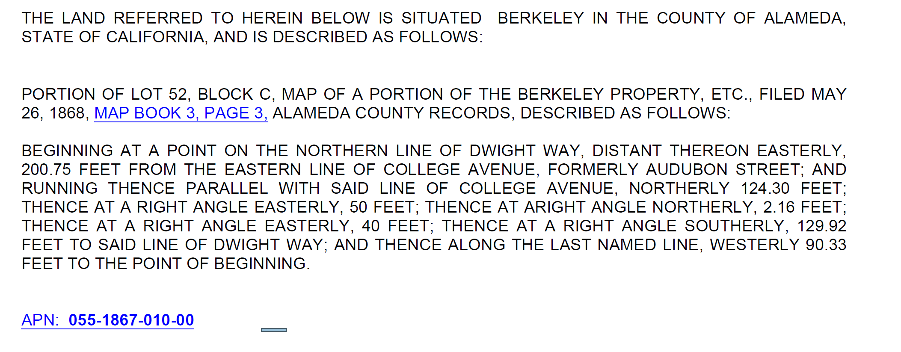

EXHIBIT B
FORM OF GRANT DEED
RECORDING REQUESTED BY AND
WHEN RECORDED MAIL TO:
_______________________________
_______________________________
_______________________________

MAIL TAX STATEMENTS TO:
_______________________________
_______________________________
_______________________________
(Above Space For Recorder’s Use Only)
The Undersigned Grantor(s) Declare(s): DOCUMENTARY TRANSFER TAX $_____________; CITY TRANSFER TAX $_____________;
[ ] computed on the consideration or full value of property conveyed, OR
[ ] computed on the consideration or full value less value of liens and/or encumbrances remaining at time of sale,
[ ] unincorporated area; [ ] City of Berkeley

GRANT DEED
FOR VALUABLE CONSIDERATION, receipt of which is hereby acknowledged, ________________________________ grants to _________________________________, all that certain real property located in the City of Berkeley, County of Alameda, State of California, which is more particularly described in Exhibit A, attached hereto and incorporated herein by this reference.

IN WITNESS WHEREOF, this Grant Deed has been executed as of the date listed below.

Dated: ____________________, 20____

GRANTOR:
________________________________

Form – Do not sign
By:
Name:
Title:
EXHIBIT C

GENERAL ASSIGNMENT

This General Assignment Agreement (this “Assignment”) is made effective as of the ____ day of _________________, 20____, by and between _________________________ (“Assignor”) and ________________________________ (“Assignee”) pursuant to that certain ____________________________ (the “Agreement”) dated as of ______________, 20___ between Assignor and Assignee. All capitalized terms used in this Assignment and not otherwise defined shall have the meanings assigned to such terms in the Agreement.

For good and valuable consideration, the receipt and sufficiency of which are hereby acknowledged, Assignor hereby assigns and transfers to Assignee all right, title and interest of Assignor in and to the following intangible property, to the extent transferable: all intangible personal property owned by Seller in connection with the Real Property, including, without limitation, any certificates of occupancy, guarantees, warranties, bonds, entitlements, permits, licenses, approvals, prepaid fees, deposits and credits, utility service agreements, waste water, storm drainage and other utility rights, credits and/or capacities, development rights and all other rights, privileges and intangible personal property appurtenant to the Real Property (collectively, the “Interests”), and the service contracts attached as Exhibit A hereto, if any (as approved by Assignee in its sole discretion) ("Contracts"). Assignee hereby accepts such assignment and transfer by Assignor and agrees to fully perform and assume all the obligations of Assignor under the Interests and Contracts assigned and transferred herein accruing from and after the Closing Date.

Assignee does hereby covenant with Assignor, and represents and warrants to Assignor, that, except as may otherwise be provided in the Purchase Agreement, Assignor is transferring the Interests and the Contracts (to the extent the terms of any of the foregoing do not limit or restrict such right) without any warranty or representation of any kind or nature. This Assignment shall not be construed as a representation or warranty by Assignor as to the transferability or enforceability of the Interests and Assignor shall have no liability to Assignee in the event that any or all of the Interests (a) are not transferable to Assignee, or (b) are cancelled or terminated by reason of this Assignment or any acts of Assignee.
This instrument shall be binding upon the parties hereto and their successors and assigns. This Assignment may be executed in counterparts, each of which shall be deemed original and all of which together shall constitute one and the same instrument. This Assignment is governed by California law without regard to principals of conflicts of laws.

IN WITNESS WHEREOF, Assignor and Assignee have executed and delivered this Assignment as of the day and year first above written.

ASSIGNOR:  _____________________________,  a ___________________________  Form – Do not sign  By:  Name:  Title: | ASSIGNEE:  _____________________________,  a ___________________________  Form – Do not sign  By:  Name:  Title:

EXHIBIT D

LEASE ASSIGNMENT

This Lease Assignment (this “Assignment”) is made effective as of the ____ day of _________________, 20____, by and between _________________________ (“Assignor”) and ________________________________ (“Assignee”) pursuant to that certain ____________________________ (the “Agreement”) dated as of ______________, 20___ between Assignor and Assignee. All capitalized terms used in this Assignment and not otherwise defined shall have the meanings assigned to such terms in the Agreement.

For good and valuable consideration, the receipt and sufficiency of which are hereby acknowledged, Assignor hereby assigns and transfers to Assignee all right, title and interest of Assignor in and to those certain Leases attached hereto (collectively, the "Leases"). Assignee hereby accepts such assignment and transfer by Assignor and agrees to fully perform and assume all the obligations of Assignor under the Leases assigned and transferred herein accruing from and after the Closing Date.

This instrument shall be binding upon the parties hereto and their successors and assigns. This Assignment may be executed in counterparts, each of which shall be deemed original and all of which together shall constitute one and the same instrument. This Assignment is governed by California law without regard to principals of conflicts of laws.

IN WITNESS WHEREOF, Assignor and Assignee have executed and delivered this Assignment as of the day and year first above written.

ASSIGNOR:  _____________________________,  a ___________________________  Form – Do not sign  By:  Name:  Title: | ASSIGNEE:  _____________________________,  a ___________________________  Form – Do not sign  By:  Name:  Title:

EXHIBIT E

PROMISSORY NOTE
[see form of Promissory Note provided by Seller]

EXHIBIT F

DEED OF TRUST

[to be replaced with standard title company short-form deed of trust with assignment of leases and rents]
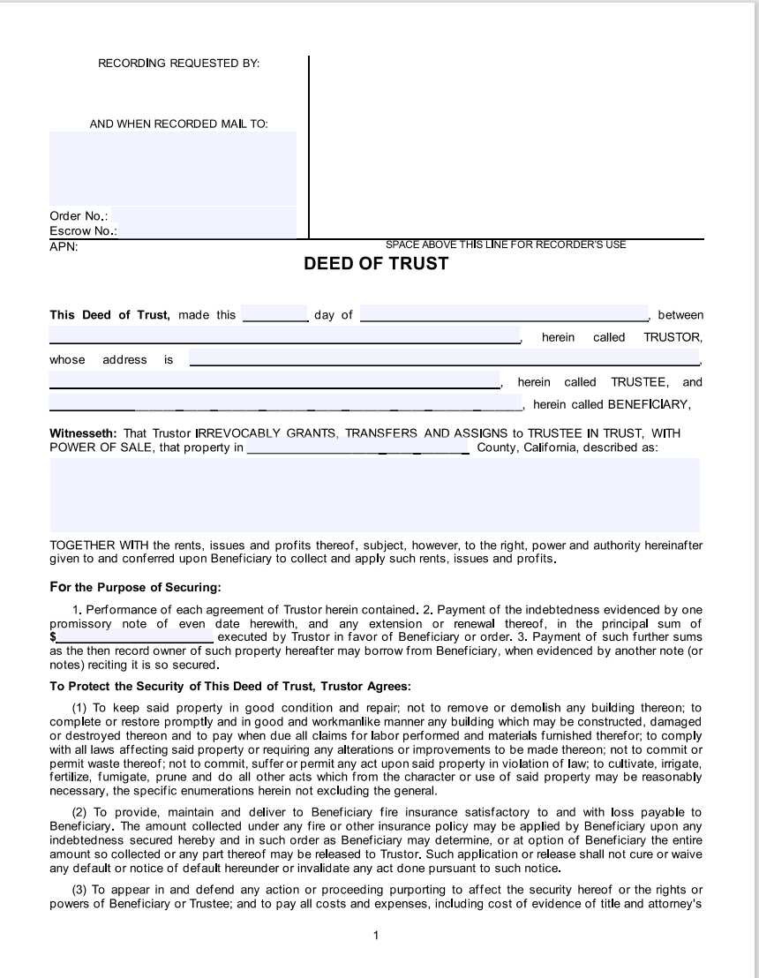
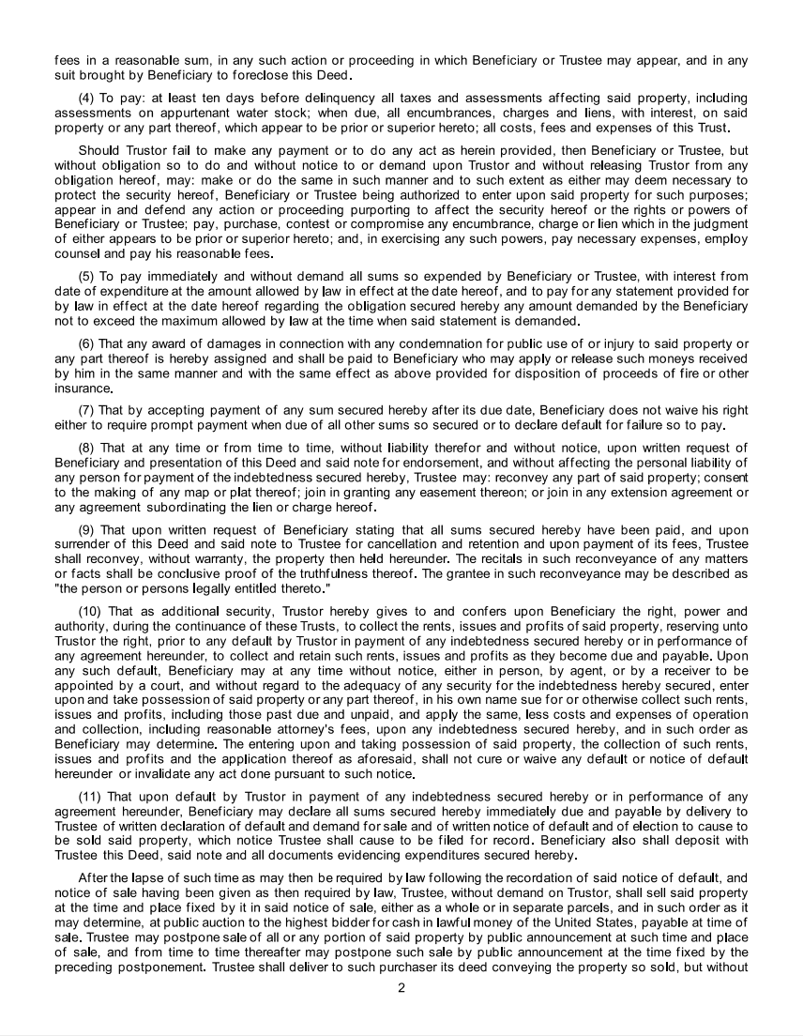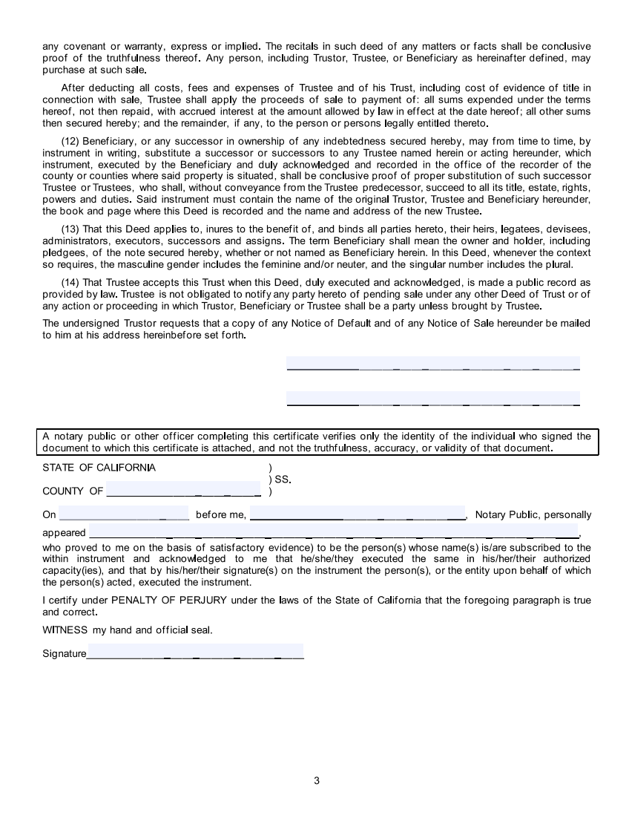

Schedule 1.9

LEASES

[DESCRIBE]

